Contents
1.Product detail 1
2.Definition 1
3.User 1
4.PRODUCT BACKLOG ITEAM 2

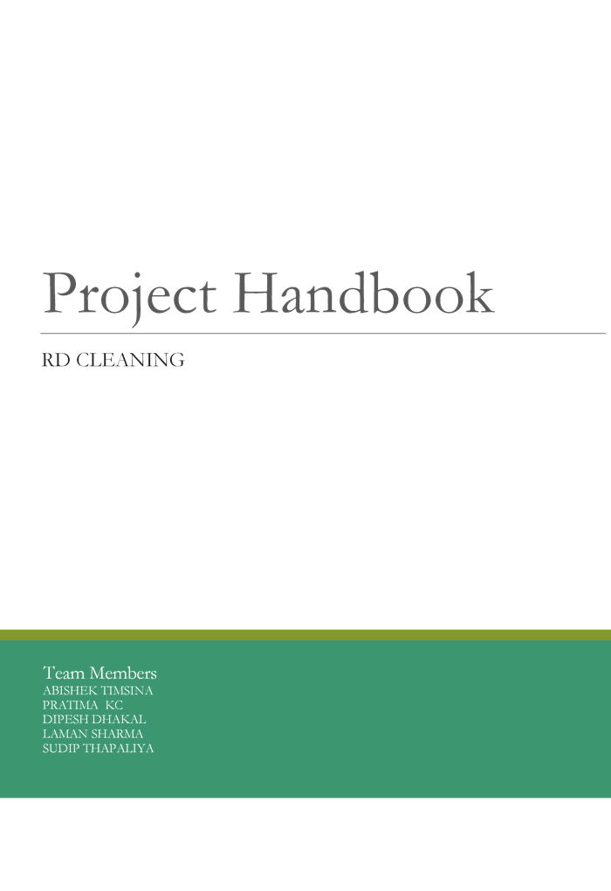

1.Product detail
We are developing the website for the cleaning company according to the requirement of our client. The aims of the project is to develop a portal for registered & existing customers to login, raise issues of concern and also monitor the reports of the daily work. The website also will list all the services undertaken by the company and used as a marketing tool for a prospective client. Through the website it would contain end to end process document as per customer perspective. Our project is to provide every function that our client needs. This website will provide every cleaning service required for the customer. The website should contain every cleaning area categorize such as house, hospital and so on. Website would explain every factor that you need to know about cleaning such the equipment, furniture and so on. Their will be every detail to contact the office or the supervisor. For the client there will be the brief description of the cleaning services ,explanation of the every product and every form they need to fill .And notification when client enter the detail to the staff or supervisor. In this website customer can post the cleaning picture also help to track every schedule that we need to follow. It will contain the every user like manager, staff, company supervisor and so on. This project include the website which contain brief description of the website, different cleaning product, contact detail where their will be client and staff login to make the website user friendly. The other aim is to design end-to-end process document from the customer perspective. We will also look forward to Implement a notification mechanism that sends email alerts and SMS notifications to supervisor, cleaners and customers. There will be Calculation of the time taken to complete each ad-hoc issue raised by the customer for reporting purpose.

2.Definition
Sign up | Creating an account for new users
Login ID | Where you can login via your ID
About us | Detail of cleaning company
Cleaning services | Services the company provide
Cleaning product | Product that is use for cleaning
Contact | Contact detail of supervisor, manager or company
Contract | Lease period for cleaning
Bills | Payment that is need to be paid by customer
Discount | Apply for cheap accommodation
Fees | The company charges
Payment | Checkout

3.User
Administration:
-A person that control every document and data access to other users and provide all the required data to the desired user. They have control to add staff or partner from managing the data and can edit the availability of the website.
Public user
-A person who has not signed up for accessing the website and can access to all allowed data by providing all required data that it ask for.
Customer
A person who is already a registered user of RD Cleaning. They can access to different document including the bills, contract, cleaning services, discount and so on.
Staff or other office personal
-A person who can access all the data in application and can approve all the public users and customer request od data. Other user can fulfill all the legal request of customer and public user.

4.PRODUCT BACKLOG ITEAM
ID | Requirement | Condition of satisfaction | Priority
US 1 | As a public user I want the sign up by entering my personal data ,so that I can access the cleaning services. | HIGH | While login to the website there will be sign up option at the top corner of website.
US 2 | As a public user I was direct access to website for existing customer. | MEDIUM | While access website if you haven’t log out you will haven’t need to login again you would have direct access to website.
US 3 | As a public user I want to know the charges done by the company. | MEDIUM | While you are inside the web page at the bottom you can find the charges.
US 4 | AS public user I want the location of the company in my area as I enter the postcode. | HIGH | While you are login the website you should turn on the location so it will automatically show the cleaning services providing near your area.
US 5 | As a user I want to know about the company and its background. | MEDIUM | While login the website there is the option called about us you can click there and find about it.
US 6 | As a user I want to know the offer or update that is provided. | HIGH | While login there is the option called advertisement you can find it there.
US 7 | As a user, I want to see the list of products available in the store. | HIGH | When you login onto the website, there will the option “List of Product”. You can click there to find it.
US 8 | As a user, I want to know which products are available and which are not in the company at certain time. | HIGH | When you login and find the list of products, there will be written “Available” for available items and “Not Available” for not available items.
US 9 | As a user, I want to find out the trading hour of the company. | HIGH | When you access the website, you will see the option “Opening Hours” and you can find the trading hour by clicking there.
US 10 | As a user, I want to find out the price of the cleaning items and also know the discount amount if it is available. | MEDIUM | When you login to the system and go to the “List of product”, you will see the entire fixed price below the list of items. If there is any discount available. It will be given next to the fixed price .
US 11 | As user, I want to see or give feedback to the company after buying the things from the shop. | HIGH | When you login to the website, on the bottom, there will be a option called “Reviews”. You can click into that and read the previous feedback and write the review there in the box.
US12 | As a user, I want to the background, contact detail and location of the company. | MEDIUM | When you login to the website, you will see the option “Background” there, location and phone number will automatically be there at front. For more contact detail, you can click on “Contact Us” on the bottom right corner.
US 13 | AS a user ,I want to show all the service specialists. | HIGH | When logged in all the services that are provided by the company is shown and a customer can easily select the services they want.
US 14 | As a user, I want to provide all the information to contact the company . | Medium | When logged in all the contact number and address can be seen easily.
US 15 | As a user ,I want to show all kind of specialized chemical and tool that are used. | High | When logged in all the tools and chemicals images are displayed.
US 16 | As a user, I want customer to see brochure if more information they want. | Low | When logged in there will be a brochure file to download if more detail information require
US 17 | As a user ,I want a place where customer as drop their reviews. | High | When logged in at the end we can see some review from the customers.
US 18 | As a user ,I want a search bar . | High | When logged in there will be a search bar at the top corner which will help the customer to find what they are looking for.
US 19 | As a user , I want the work to be systematic. | LOW | When log in there will be detail what time you log on and log off.
US 20 | As a user, I want online payment. | High | When log on there will be option called payment where you can go and look for it.
US 21 | As a user, I want to see all the services available in the site. | HIGH | When log in to the website there will be option called services.
US 22 | As a user , I want the website to be simple so it will be easy for everyone. | HIGH | The website will be designed in a simple way which make easy to use.
US 23 | As a user, I want company to keep detail of their staff members. | MEDIUM | When you logged in there will be the option called roster you can check their.
US 24 | As a user, I Want the see the availability of each worker group. | MEDIUM | When you logged in you can check inside the roster and it will should availability .
US 25 | As a user, I want to know the about the product used by company whether they are suitable for children or not and harmful for or health | MEDIUM | When you login to company website, you can find all these information under products details.
US 26 | As a user, I want to know the services provided by company | MEDIUM | After you login, you find services on top right under your account.
US 27 | As a user, I want to know the availability of employee on needed time. | MEDIUM | After you login, you can see employee online on home page and you can contact to those on line.
US 28 | As a user, I want to know how reliable service the company provides. | MEDIUM | Before you login, you can go to review of company homepage at top down.
US 29 | As a user, I want to know if company provide regular home service to older ,needy people or not. | MEDIUM | After you login, you can see menu on homepage on left corner and go to services and check the regular option.
US 30 | As a user, I want to know time taken by cleaners after finishing job. | MEDIUM | After you login, you can see this on clearness profile on cleaner icon.

